Simulator development for yield estimation (in case of corn, oats, soybean) based on weather-data
Marcell Pitlik, Dániel Váradi, László Pitlik, MY-X team
Abstract: There are given information units about yields and weather constellations. The yields and weather data are available for well-known regions for more than 100 years. Yields are annual data, the weather is descripted in daily rhythm (through average temperature, minimum, maximum temperature, and precipitation). All time-series have different lacks: e.g., not all the plants were produced in all regions in all years and/or weather data could not be measured for each day - therefore the daily weather data are in general not given for all the days. This situation should be accepted as a real data management situation. The region (US-state) is Minnesota with a lot of counties as production areas. Weather stations are given more than production areas, and the GPS-coordinates of production areas and weather stations present arbitrary differences.
The task is simple: a simulator should be developed where yields of the plants (at first corn, oats, soybean) can be derived based on weather data. The developer is free: the developer may decide about the model inputs (based on the prepared data assets: https://miau.my-x.hu/miau/298/quant). The test of the simulator is also simple: there are 198 regions (without GPS co-ordinates but with differently completed weather data, it means for different years and with different lack in the time-series). The simulator should deliver yields for the unknown regions based only on their weather data for each year where at least one single weather data is given.
Solution: It is possible, based on antidiscrimination models of the own similarity analysis tool (https://miau.my-x.hu/myx-free/) to derive the most similar (well-known) region (with well-known soil/environment-reactions) for each unknown region based on the two sets of different weather data. The similarity analysis is capable of searching for the most similar weather situation based on daily and/or aggregated differences in form of an online Solver-oriented approach. If the most similar region is given, then its weather data and yields can be used for region-specific simulator development.
The region-specific simulator development is also a similarity-driven approach where production functions (with staircase functions in the core system) are estimated: e.g., monthly averages for average temperature, minimum, maximum temperature and precipitation can be derived based on the available data for each year (covering the partial data lack). It means averages (as Xi) are responsible for the US-state Minnesota as such. The average yield (at first unweighted) can also be derived in frame of a pivot table as a kind of Y values for the modelling.
These average yields demonstrate a massive increasing trend between 1950-2021. There are data available before 1950 (source USDA: quick stats – with data from 1921). The linear trends for different plants (corn, oats, and soybean) can be estimated with R2-values over 0.9. Polynomials (3th) (it means S-curves) deliver higher R2-values – concerning the expectations. The nominal yields can be transformed into weather-impact-values if the difference is calculated between the raw yield and the trend-based yield (year-by-year). The simulators for raw yields (where the inputs are the monthly weather data of the previous year) are error-free in the learning phase but the test year (2022) presents a potential yield between 0 and the genetic potential. It means: these models are still not useful. If the dependent variable is not the nominal (raw) yield (in BU/acre) but the transformed yield (see weather-impact - based on the linear trends) and let alone not for the same year but for the next one, then the simulators are also error-free – and these models/simulators are capable of real estimations (forecasts) for corn/oats/soybean.
Conclusion: the corn for the entire Minnesota should deliver a yield in case of 2022 over the well-known maximum yield before! The soyabean should deliver a yield better than in 2021. Oats yield should also be higher than in 2021. These estimations could be checked based on available data by USDA (e.g., https://quickstats.nass.usda.gov/). All these estimations can be evaluated as correct! It means this kind of simulator development (with real forecasting characteristics) is robust enough for entire Minnesota and the logic can be adapted for arbitrary (known and unknown=estimated) regions (counties) based on the antidiscrimination pre-analysis in case of each seemingly unknown test region. The automation of the already tested and robust development-process is trivial if the decision makers give a sign of willingness.
The above-descripted approach is a kind of consistence-driven method for developing simulators (production functions). Consistence means the partial results can be interpreted compared to each other as useful/appropriate puzzle pieces. If these puzzle pieces can not join with each other, the simulators will not gossip like chatGPT would do in such a case. Parallel, the similarity analyses have an internal quality assurance layer: the mirrored inputs should deliver mirrored outputs. If these double checking is not given, then the simulators will not gossip for affected years and/or regions.
Keywords: forecasting, antidiscrimination, weather, yield, production function, consistence-oriented modelling

Introduction
The estimation of agricultural yields for plants (or even for animal products) is a well-known challenge since the existence of the human mankind. Production functions where the production inputs and the outputs are given for the same year describes the basic relationships between inputs and outputs: c.f. ceteris paribus function e.g., with linear increasing effects + linear plateaus (like in case of Y=intensity of photosynthesis ad X=CO2-concentration in case of one single example of a plant). Ceteris paribus functions seems to be sigmoid (https://miau.my-x.hu/mediawiki/index.php/Cs%C3%B6kken%C5%91_hozad%C3%A9k_elve, and/or https://cms.sulinet.hu/get/d/8ffa2618-a9ac-45e0-b6f5-fb121b95aabe/1/1/b/Normal/a%20csokkeno%20hozadek%20elvenek%20bemutatasa%20fuggvenyek%20segitsegevel_webnormal.jpg) in case of more (genetic partially different) examples of plants.
The Liebig’s law of the minimum (c.f. https://en.wikipedia.org/wiki/Liebig%27s_law_of_the_minimum and/or https://arcosaspecialtymaterials.com/wp-content/uploads/2020/06/Liebigs-Law-of-Minimum-600x600-1.png) says, the relationships of the production inputs is special: inputs can not be substituted by each other. The well-known production function (for education of micro-economics) make possible these substitutions. It means: the problem is complex and not solved for thousand of years. Not even in frame of the precision farming where data about micro areas (it means e.g., <10 square meters) are given about the quasi entire agricultural technology (c.f. yield mapping, seeds, NPK, etc.).
The linear approximations can also be criticized (see Figure#1 and Figure#2 about yield time-series in shorter and longer periods):
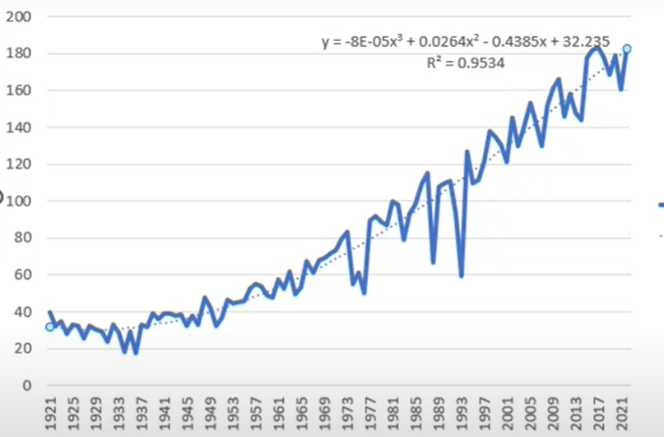
Figure#1: Corn yields with polynomials (based on USDA statistics) – (source: own presentation – mp4-cut from an online lecture about the quant challenge: https://www.quantchallenge.hu/)
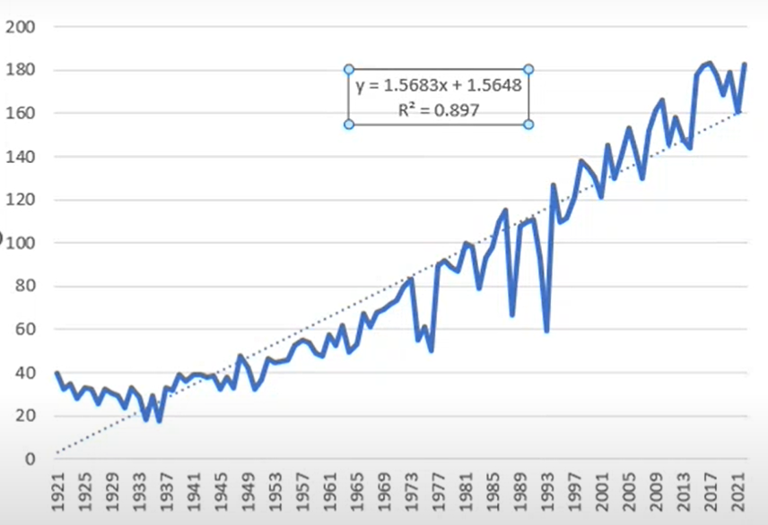
Figure#2: Corn yields with linear trend (based on USDA statistics) – (source: own presentation – mp4-cut from an online lecture about the quant challenge: https://www.quantchallenge.hu/)
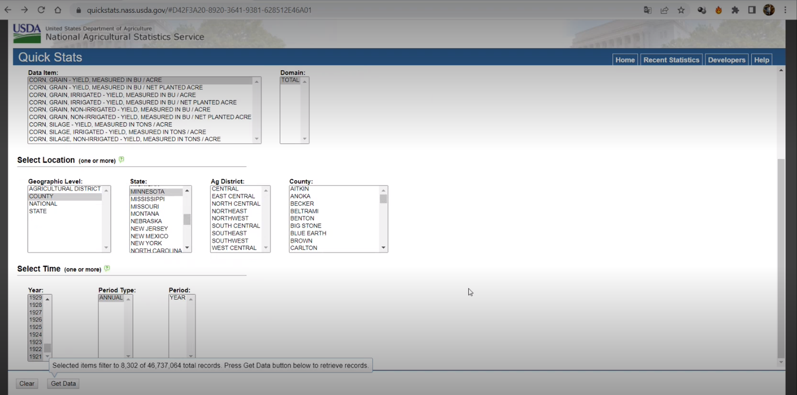
Figure#3: USDA QUICK STATS – DYNAMIC OLAP SERVICES (source: own presentation – mp4-cut from an online lecture about the quant challenge: https://www.quantchallenge.hu/)
Figure#3 presents a query from USDA QUICK STATS in order to download time-series of yields before 1950 for corn.
Conclusions: The estimation of production function can be reduced only to calculation with weather patterns, but the accuracy and even the logical stability of this kind of models seems to be to low because the impacts of the soil/geography/hydrology/etc. are massive (c.f. Figure#4):
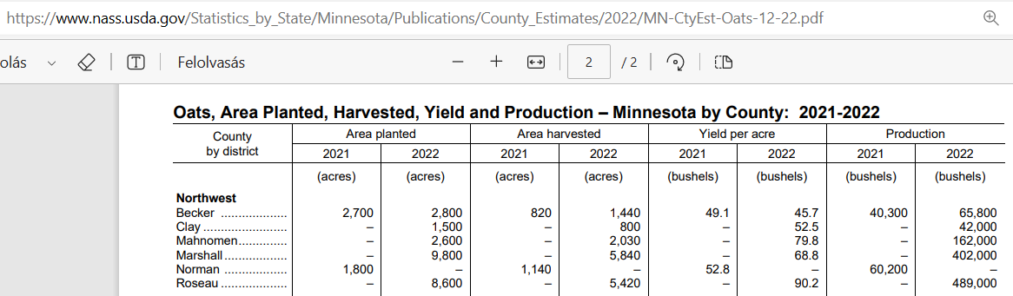
Figure#4: Yield-differences within a subregion (Minnesota – Northwest) in case of soybean – source: USDA
Figure#4 demonstrates a yield-difference of “1:2” (90.2 vs. 45.7) in the year of 2022.
On the other hand, a simulator based only the weather inputs may involve quasi each data being available (like in case of picture/video-interpretations) where the output will never be explainable, but the classification level can be maximized.
The so-called unknown region in the reality can not be seen as unknown. They can be located based on the weather-similarities between known and unknown objects. The sporadic weather data should be aggregated to compensate the lacking positions. Aggregations can be statistical characteristics like averages e.g., for months. In case of the year of 2022, there is given only data for 6 months (concerning the weather). Therefore, a classic descriptive simulator with data about the same year for inputs and outputs could only be constructed if a kind of weather-forecast is also integrated into the modelling.
Climate change effects are also mentioned in the Morgan Stanley Quant Challenge, but a simulator does not have any climate characteristics.
Based on all these influential impacts, this article is a special documentation concerning the Quant Challenge. Our team will present following potentials as elements of a complex system needing optimized according to the Customer’s real, precise expectations:
- It is possible to identify the GPS-coordinates of the so-called unknown regions and
- therefore, it is possible to create a lot of GPS-oriented simulators…
- It is also possible to create simulators where the inputs are monthly averages concerning the given weather data (which interpretation makes possible to handle the arbitrary lacking data-positions).
- It is possible to create forecasting models in order to exclude explicit weather forecasts (c.f. for 2022: July-December) and so ensure a yield-estimation for 2022.
- It is possible to derive lacking weather data with non-causal models (NCMs).
- It is possible to test the above listed developments - partially…

Data asset
The following subchapters (GPS, plants) demonstrate the most relevant interpretation of the data quantity and quality:

GPS-oriented views
The GPS-coordinates are given for 87 production areas (c.f. counties) and for 97 weather-stations (see Figure#5):
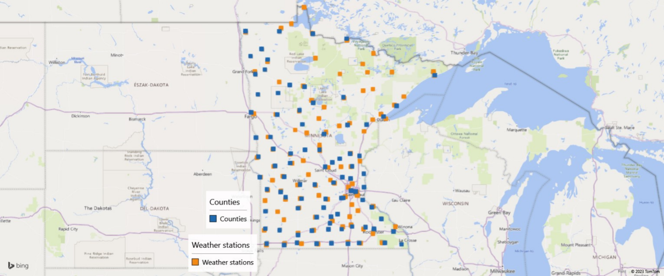
Figure#5: Relationships of 87 counties and 97 weather-stations (own presentation – based on Google maps)
Figure#6 presents the hunting process in case of a seemingly unknown regions (e.g., KJMR0 + ACAvNTuEuFWcmwms based on 1 random chosen file of 198 so-called trigger files about weather data of an unknown region and known production region near/next to the localized weather-station).
Figure#6 shows the localized region (Kanabec – red highlighted in the middle of the map). Above the localized region, there are 3 further points. They are the most similar points concerning their weather. Below the red-highlighted point, there are 3 other points. They are the less similar ones.
Figure#7 presents the coordinates for the most similar weather-station among the known objects.
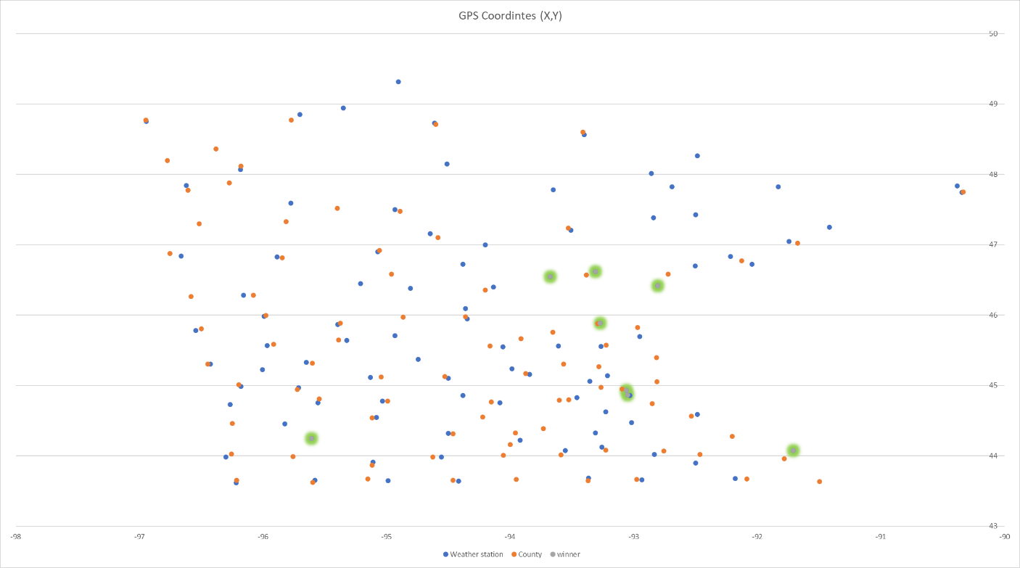
Figure#6: Localisation of seemingly unknown regions (source: https://miau.my-x.hu/miau/298/quant_gps.xlsx)
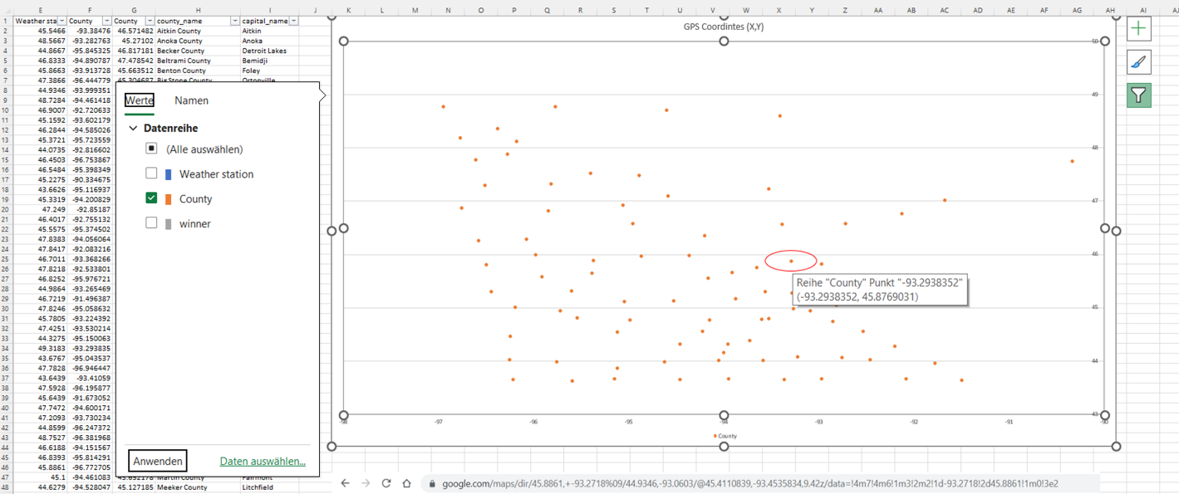
Figure#7: The coordinates of the most similar weather-station (source: https://miau.my-x.hu/miau/298/quant_gps.xlsx)
Figure#8 is a map, where the localized unknown region and the opposite of it can be seen: More (Kanabec) and Minneapolis ca. 80 miles difference, incl. height-difference (ca. 300 foots) and the Mississippi-effect as such.

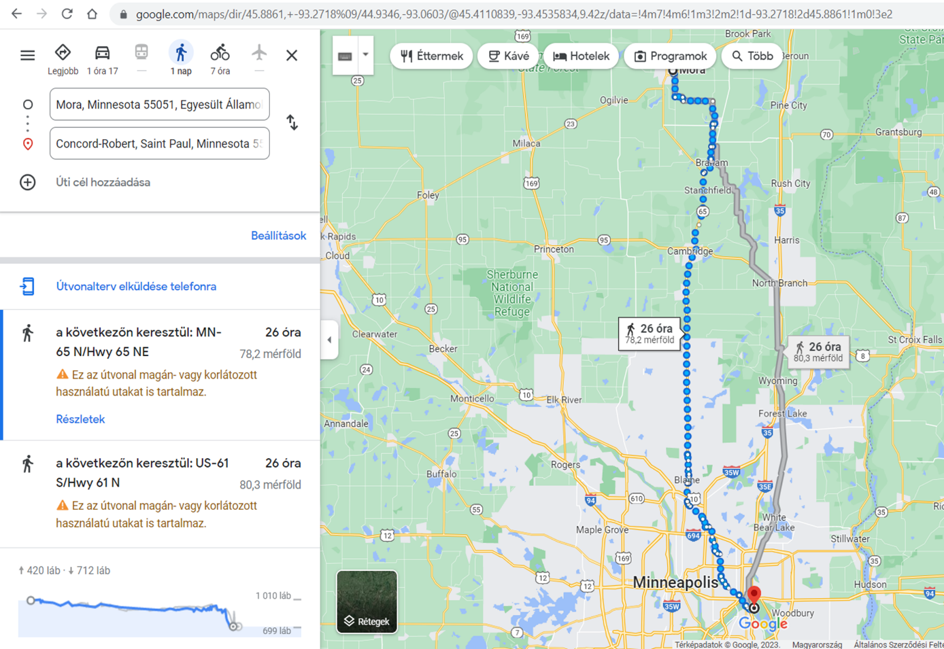
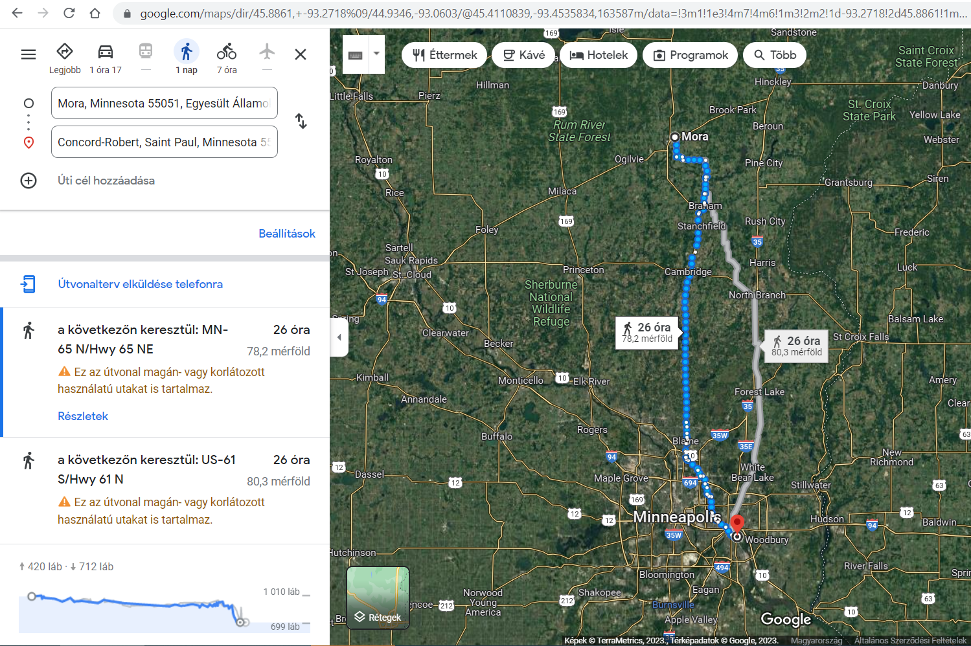
Figure#8: Mora vs. Minneapolis – the Mississippi-effect (source: https://miau.my-x.hu/miau/298/quant_gps.xlsx)

Quant_gps.xlsx presents the steps of the own antidiscrimination similarity analyses:
- Pattern-derivation for the 97 known weather-stations (12 months 4-4 averages = 48 attributes).
- Pattern-derivation for the random chosen unknown region (the same attributes).
- Derivation of the absolute differences concerning the pattern of unknown region.
- OAM with 97 regions and 48 real attributes (differences).
- Y = constant value for all objects.
- Model-hypothesis: each pattern of the known regions can be seen as similar enough compared to the pattern of the unknown region.
- First step: yes, each region could be seen as the same, but 8 attributes of the 48 set were not integrated in order to derive the sameness-like status.
- Second step: OAM with 97 objects and 8 (unused) attributes should also be analysed (Y=constant values, model-logic: antidiscrimination similarity analysis: https://miau.my-x.hu/miau/196/My-X%20Team_A5%20fuzet_EN_jav.pdf).
- The expected result is trivial, one of the 97 potential GPS-coordinates (average-based weather-pattern) wins as the most similar one.
- Map-based checks for similar and not similar alternatives.
Conclusion: each of the 198 trigger-dataset could be localized in an automated process, if the Customer’s expectation let derive information added-values for this kind of software development.
The testing process for the above-mentioned steps can not be holistic because the real GPS-coordinates are not public. This is the decision of the so-called “Customers” of this development project.
On the other hand: the map-oriented relationships of the massive similar and the massive non-similar objects seems to be rational (consistent).

Plants
The following figures present relevant patterns concerning the plants corn, outs, soybean (where each other plants could have been integrated into this pre-analytical process):

Corn
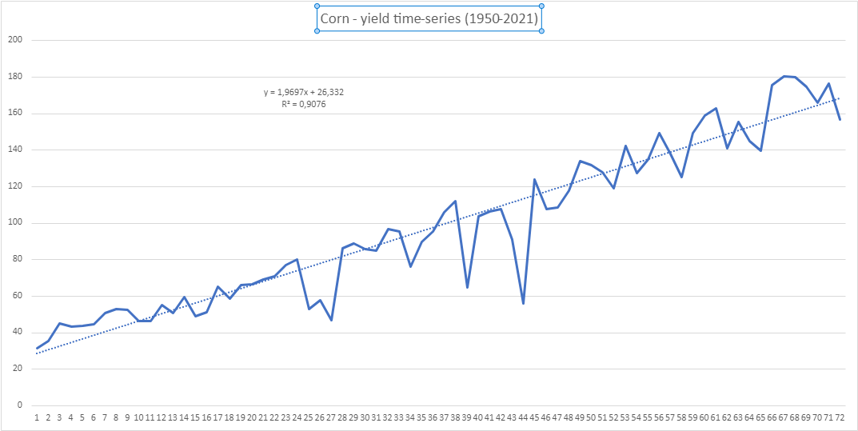
Figure#9: Corn yields in bushel/acre (source: own presentation)
Figure#9 presents the time-series of the corn yields between 1950-2021. The linear trend (c.f. Figure# and Figure#2) seems to be robust for excluding/deriving agrotechnical and/or genetic developments during the years (c.f. Figure#10):
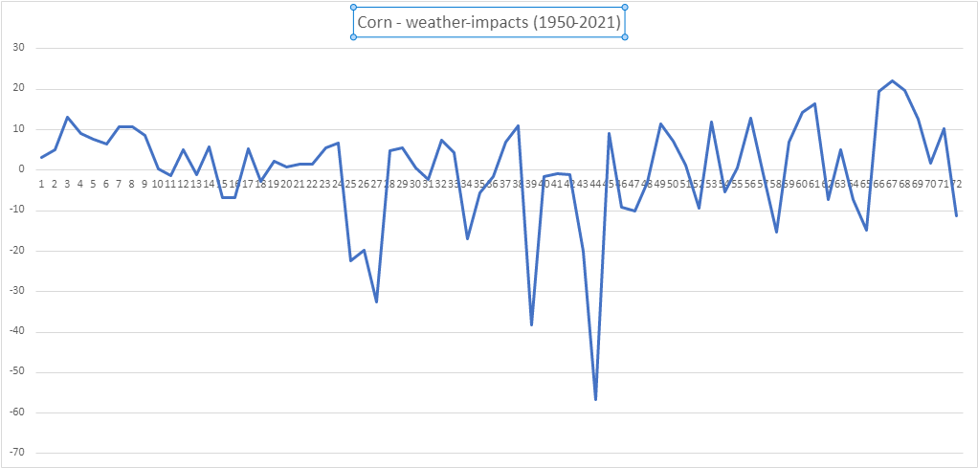
Figure#10: Differences between raw corn-yields and trend-based corn-yields in bushel/acre (own presentation) – called also as transformed corn yields or weather impacts (source: own presentation)
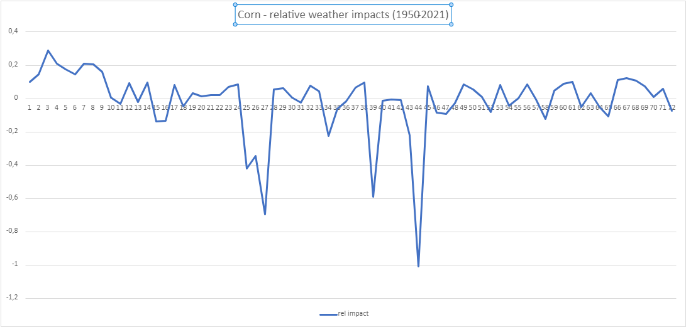
Figure#11: Weather impacts compared to the raw yields in case of corn (source: own presentation)
Conclusions: There is not trivial after comparing Figure#10 and Figure#11 whether the climate change as such could be derived (in form of higher frequencies and higher amplitudes along the time).
The data from Figure#10 will be used for further modelling (as Y values in the OAM for simulation and forecasting).

Oats
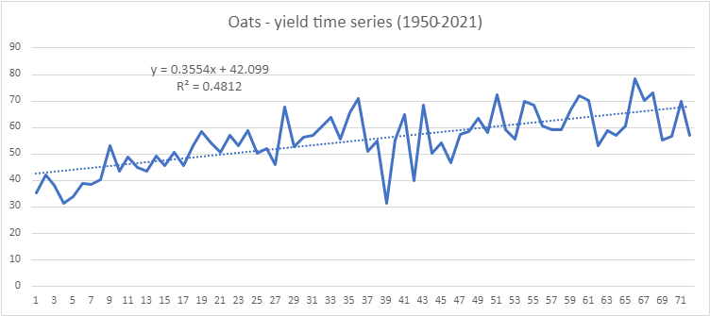
Figure#12: Oats yields in bushel/acre (source: own presentation)
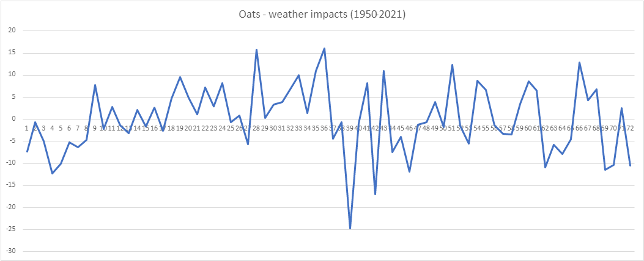
Figure#13: Differences between raw oats-yields and trend-based oats-yields in bushel/acre (own presentation) – called also as transformed oats yields or weather impacts (source: own presentation)
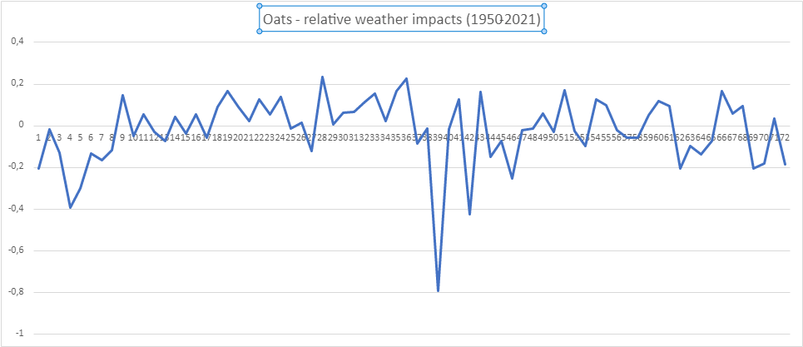
Figure#14: Weather impacts compared to the raw yields in case of oats (source: own presentation)
Conclusions: There is also not trivial after comparing Figure#13 and Figure#14 whether the climate change as such could be derived (in form of higher frequencies and higher amplitudes along the time).
The data from Figure#13 will be used for further modelling (as Y values in the OAM for simulation and forecasting).

Soybean
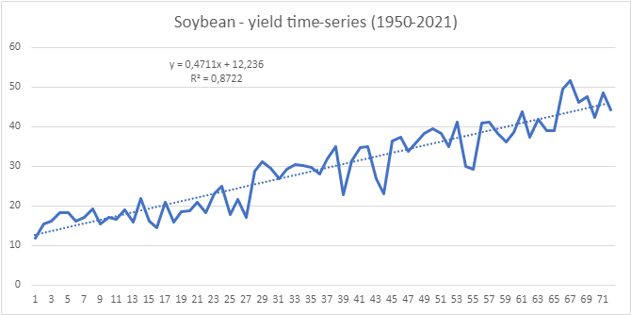
Figure#15: Soybean yields in bushel/acre (source: own presentation)
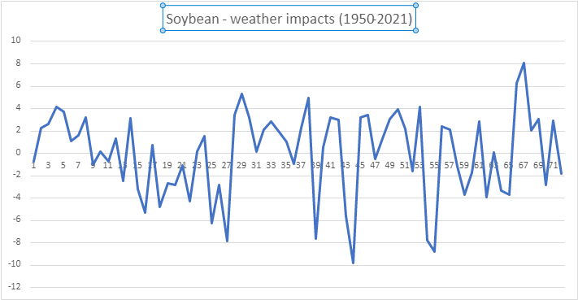
Figure#16: Differences between raw soybean-yields and trend-based soybean -yields in bushel/acre (own presentation) – called also as transformed soybean yields or weather impacts (source: own presentation)

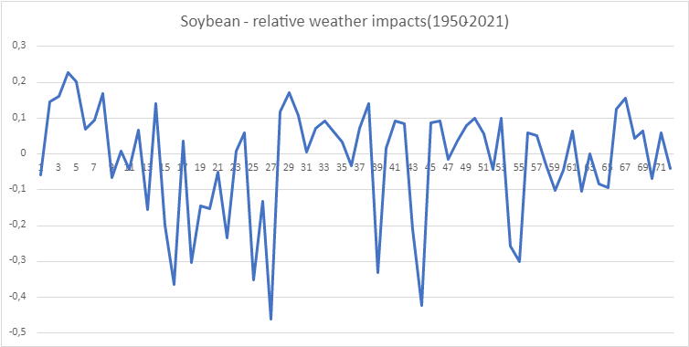
Figure#17: Weather impacts compared to the raw yields in case of soybean (source: own presentation)
Conclusions: There is not trivial after comparing Figure#16 and Figure#17 whether the climate change as such could be derived (in form of higher frequencies and higher amplitudes along the time).
The data from Figure#16 will be used for further modelling (as Y values in the OAM for simulation and forecasting).

Models
X-attributes: 12 months with 4-4 weather-characteristics (such as average temperature, maximum temperature, minimum temperature, and precipitation) = 12*4=48 direct (the more X, the more Y) attributes and further 48 inverse attributes (the less X, the more Y). Y variables: raw yields and transformed yields (=raw_yield-trend_yield).

Error-free COCO-models
- Corn, 2*48 X-attributes, raw yields as Y
- Corn, 2*48 X-attributes, transformed yields as Y (see Figure#3)
- Corn, 2*48+2 X attributes (incl. time direct and invers views), raw yields as Y
- Corn, 2*48+2 X attributes (incl. time direct and invers views), transformed yields as Y
- Oats, 2*48 X-attributes, raw yields as Y
- Oats, 2*48 X-attributes, transformed yields as Y (see Figure#3)
- Oats, 2*48+2 X attributes (incl. time direct and invers views), raw yields as Y
- Oats, 2*48+2 X attributes (incl. time direct and invers views), transformed yields as Y
- Soybean, 2*48 X-attributes, raw yields as Y
- Soybean, 2*48 X-attributes, transformed yields as Y (see Figure#3)
- Soybean, 2*48+2 X attributes (incl. time direct and invers views), raw yields as Y
- Soybean, 2*48+2 X attributes (incl. time direct and invers views), transformed yields as Y
- …

Non-Causal Model(s) (NCM)
Non-causal models are Excel Solver-based models (c.f. https://miau.my-x.hu/miau2009/index.php3?x=e0&string=l.v.radi, https://miau.my-x.hu/miau/296/joker2_for_biological_systems_full.docx), which, in this case, are following an simple logic and pattern on forecasting the sum average weather conditions for the second half of the year 2022, which were missing in the given dataset. This model takes into consideration the correlation between time (years – as a kind of specific dependent variable/Y) and the sum average values per month and year of the known and missing average, minimum, maximum, precipitation values. To make the model more consistent (more restrictive) we also included the average, std. deviations. Of course, a part of this, we also implemented the logical patterns as between average, minimum, maximum values. When looking at the visualisation of the results (see Figure#18 and Figure#19) the output values are integrating “perfectly” (it means: Turing-test-based) into a reasonable interval, even in the case of month 11.2022 and 12.2022 where the output results in many cases were 0. Meanwhile testing these results with COCO-STD OAM the dataset with the technology and weather effects(Y) were error free. Those datasets where the Y values were not containing the weather/technology effects were not error free but forecasted a massive rise from 2021 to 2022.

Figure#18: (source own presentation)

Figure#19: (source own presentation)

Simulations based on similarity analyses
The simulations tried to interpret following hypotheses: Whether it is possible, that the weather-patterns the yields and/or the weather-impacts are capable of modelling in an error-free way?
YES-layers:
- Corn (2*48 X-attributes): rawY(2022)=rawY(2021)
- Corn (2*48 X-attributes): rawY(2022)=0
- Corn (2*48 X-attributes): rawY(2022)>known maximum yield
- Corn (1*48 X-attributes): rawY(2022)=rawY(2021)
- Corn (1*48 X-attributes): rawY(2022)=0
- Corn (1*48 X-attributes): rawY(2022)>known maximum yield
- Soybean (2*48 X-attributes): rawY(2022)=rawY(2021)
- Soybean (2*48 X-attributes): rawY(2022)=0
- Soybean (2*48 X-attributes): rawY(2022)>known maximum yield
- Soybean (1*48 X-attributes): rawY(2022)=rawY(2021)
- Soybean (1*48 X-attributes): rawY(2022)=0
- Soybean (1*48 X-attributes): rawY(2022)>known maximum yield
- Oats (2*48 X-attributes): rawY(2022)=rawY(2021)
- Oats (2*48 X-attributes): rawY(2022)=0
- Oats (2*48 X-attributes): rawY(2022)>known maximum yield
- Oats (1*48 X-attributes): rawY(2022)=rawY(2021)
- Oats (1*48 X-attributes): rawY(2022)=0
- Oats (1*48 X-attributes): rawY(2022)>known maximum yield
- …
NO-layers:
- Corn (1*48 X-attributes - direct): transformedY(2022)= transformedY(2021) Y(2022)>Y(2021), instead of -12% rather not irrational a top yield reality=top yield
- Soybean ((1*48 X-attributes - direct): transformedY(2022)= transformedY(2021) Y(2022)>Y(2021), instead of -2% rather -8/+10% reality = soft yield increasing
- Oats ((1*48 X-attributes - direct): transformedY(2022)= transformedY(2021) Y(2022)>Y(2021), instead of -3% rather -2% or even not irrational a top yield reality = soft yield increasing
- …

Further results
This chapter summarizes the experiences with one random chosen trigger-file – identified as a neighbour of Kanabec:

Estimations without further models
Figure#20: Yield-estimations for Kanabec (source: own presentation incl. USDA-yield-maps) - https://miau.my-x.hu/miau/298/quant_gps.xlsx
For the object-ids “KJMR0 & ACAvNTuEuFWcmwms”, there are no yields for corn given, but it is possible to estimate = adapt corn-yields based on the similarities between Kanabec and the observed unknown region. This adaption is weather-driven (based on the above-mentioned GPS-relocation-process) but it is not a weather-based simulator as such.

Yield-estimations with COCO-models
Source: https://miau.my-x.hu/miau/298/quant_kanabec.xlsx
Steps of the analysis (in case of corn):
- Deriving the weather-pattern for Kanabec (only 12*3 attributes because of lacking precipitations).
- Deriving trends for the given (10 years).
- Deriving weather impacts (Y).
- Testing simulation possibilities (same year for Xi and Y=raw yield) correlation is only 0.85 without precipitation after 3 steps.
- Deriving models with Y=weather-impact (Y[year]-Y[year]=1).
- Deleting specific attributes in 6 steps.
- Deriving scenarios:
  - impact(2021)=impact(2022)2022 should be better
  - …
  - Impact(2022)=+10% (over trend-line)quasi equilibrium
- Testing nominal yield-estimations:
  - USDA: corn-yield(2021) = 110 bu/acre (67% weather impact)
  - USDA: corn-yield(2022) = 173.9 bu/acre
  - Model-estimation(2022) = 181.6 bu/acre (110% weather impact)

Conclusions
The Costumers seem to need a simulator which is working based only on weather data – with a risk of the lack of an explainable system. The presented elements (approaches) promise an alternative system, where the locations are relevant. The first tests let assume, that this location-driven approach with real forecasting potential (for 2022) can be interpreted as LEGO-pieces for a new estimation system.

Future
The construction processes based on the presented LEGO-pieces can be automated, but it is a kind of optimization challenge. It should be known e.g., what kind of errors which financial consequences will cause?! The available data quality is quite low, e.g., the USDA seems to have better a data asset.
The most robust challenge in the future would be to integrate data for the most similar (known) regions, because the one-region-one-model-logic can lead to rel. small OAMs…

References
…URLs in the article as content-sensitive hyperlinks…

It is important to highlight: it is not permitted to involve arbitrary public data/information into the analytical process!
COCO = component-based object comparison for objectivity - https://miau.my-x.hu/miau/196/My-X%20Team_A5%20fuzet_EN_jav.pdf (online similarity analysis tool: https://miau.my-x.hu/myx-free/index_en.php3 )
https://www.nass.usda.gov/Statistics_by_State/Minnesota/Publications/County_Estimates/2023/MN-CtyEst-Corn-02-23.pdf
https://www.nass.usda.gov/Statistics_by_State/Minnesota/Publications/County_Estimates/2023/MN-CtyEst-Soybeans-02-23.pdf
https://www.nass.usda.gov/Statistics_by_State/Minnesota/Publications/County_Estimates/2022/MN-CtyEst-Oats-12-22.pdf

